7.1 Significance of Speed
1.
- Because it obstructs the flow of traffic
- Because it increases the danger of rear-end collisions
- Because it encourages vehicle drivers behind to overtake dangerously
2.
- On bends
- At pedestrian crossings
- At crossroads and junctions
3.
- At blind corners
- At level crossings
- At road narrowings
4.
- (Speed in km/h / 10) x 3
- (Speed in km/h / 10) x 5
- (Speed in km/h / 10) x (Speed in km/h / 10)
5.
- When you have already been driving at high speed for some time
- When the road is wide and there are no trees, buildings, fences etc. at the edge of the road
- When the roadside features (trees, houses, fences) are constantly changing
6.
- Driving for a long time at high speed
- Driving on a good, wide road
- Loud engine and tyre noise
------------------------------------------------------------------------------------------------------------------------------------------------------
7.2 Choice of Speed
1.
- Near construction sites
- At junctions with farm tracks
- At innercity crossroads
2. Within ____________
- The stretch of road visible to me
- Half the stretch of road visible to me
- Twice the stretch of road visible to me
3.
- Heavy oversteer
- Driving too fast
- Gently accelerating at the exit of the bend
4. I may ______________
- Not exceed the permissible maximum speed for these tyres
- Only drive as fast as when I am using snow chains
- Not exceed 80 km/h
5. The maximum speed of 190 km/h ___________
- May not be exceeded
- Applies to wintry road conditions only
- Does not apply to dry road conditions
6.
- Braking distances are greater
- Wheel-spray can impair visibility
- The contact between the tyres and the roadway deteriorates
7.
- On bridges
- On stretches of road running through forest
- On frequently used stretches of road
8.
- Wet leaves as well as white forest, black ice and snowy surfaces are particularly dangerous above all on cambered roadways
- White frost and black ice occur more frequently and more unexpectedly on cobbled roadways than on other roadways
- Tree-lined avenues are particularly safe in winter because the treetops protect the road from snow
9.
- Braking
- Accelerating
- Steering wheel movements
10.
- By carefully applying the brakes at very low speed
- By jerking the steering wheel to the left and right
- By rapid acceleration
11.
- Near rivers
- Near lakes
- In marshy areas
12.
- Increase the distance from the vehicle in front
- Adapt your speed in time to visibility conditions
- Drive up close to the vehicle in front so you can use its rear lights as an orientation point
13.
- Reduce speed before reaching the bend
- Only accelerate again when the road straightens out
- Reduce speed only when you reach the centre of the bend
14.
- Soiled roadways
- Slow farm vehicles
- Excessively wide farm vehicles
15.
- Personal driving ability
- Visibility and weather conditions
- The condition of the road and traffic conditions
16.
- High speed
- Worn tyres
- Grooves in the roadway
17.
- Reduce speed
- Steer against the wind
- Accelerate rapidly
18.
- Because visibility is reduced
- Because braking distance is increased
- Because aquaplaning (sliding on wet roads) can occur
19.
- Change in tyre noise
- Danger of sliding and skidding
- Longer reaction distance
20.
- There are particularly narrow and blind bends
- The narrow and often cambered roadway requires special caution when there is oncoming traffic
- The trees provide protection from the sides
21.
- Where there are grooves in the roadway
- In dips in the roadway
- At level crossings
22.
- The vehicle can no longer be steered and braked
- The vehicle can leave the road
- Steering becomes heavy
23.
- Bad visibility immediately upon switching the windscreen wipers
- A dangerous greasy film on the surface of the road
- Shorter braking distance
24.
- Because visibility may become worse and the windscreen wipers do not immediately provide a clear field of vision
- Because a greasy film may form which increases the braking distance
- Because the brakes react more quickly
25.
- No, because it could represent a danger to oncoming traffic
- Yes, if fog headlamps and rear fog lamps are switched on
- Yes, because it reduces the risk of running off the road
26.
- Adapt speed immediately to visibility conditions
- Switch on dipped headlights
- Only switch on parking lights
27.
- Switch on the windscreen wipers from time to time when it is foggy
- When there is slush, switch on the windscreen wipers already before slush is thrown onto your windscreen by other vehicles
- When the windscreen is steamed up, switch the ventilator off and keep the windows closed
28.
- It may be necessary to stop within half the visible distance when a wide vehicle is coming from the opposite direction
- To estimate the lateral distance to the trees and oncoming traffic simultaneously
- Rapidly changing light conditions make it easier to estimate lateral distances
29.
- It is suddenly hit by a gust of strong side wind
- A burst tyre
- Sudden headwind
30.
- Driving in a slightly staggered position in your own lane
- Watching the queue through the windows of the vehicles travelling in front
- Keeping your hazard warning lights switched on when driving
31.
- 50 km/h
- 70 km/h
- 90 km/h
32. Stopping distance = 25 m
33. Speed of snow chain = 50 km/h
34. Within the range of
- Dipped headlights
- Main beam lights
- Side lights
35.
- Conflicts can arise with the oncoming traffic
- I may only drive at a speed that allows me to stop within half of my range of vision
- I have to anticipate unevenness at the edge of the carriageway caused by tree roots
36.
- After hilltops
- In forested areas
- In front of schools
37.
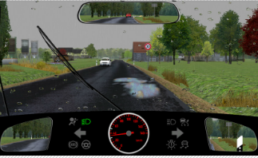 | a) I notify the fire brigade  b) I avoid heavy braking and abrupt steering movements  c) I swerve onto the left-hand side of the road
38.
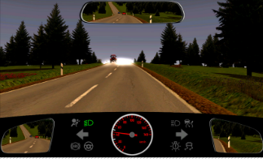 | a) I reduce my speed  b) I keep towards the right-hand edge of the carriage way  c) I switch on my main beam lights

39.
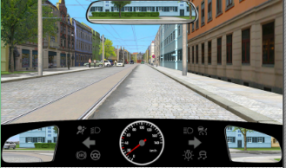 | a) Driving on the tracks is dangerous  b) The road surface is uneven and road grip varies  c) A tram might come from the opposite direction
40.
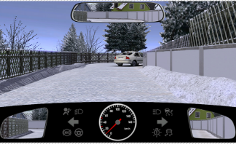 | a) Because the roadway is slippery  b) Because the view is obscured by the bend  c) Because the roadway is made narrower by the wrongly parked car
41.
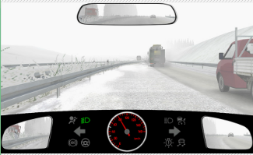 | a) There is still slush on the overtaking lane  b) Slush could be thrown up and impair visibility  c) Because beneath the slush there could also be ice on the road
42.
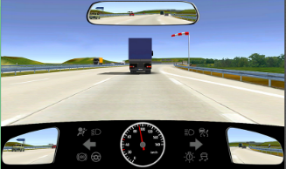 | a) When overtaking, your vehicle is pulling to the right when you enter the slipstream of the truck  b) Your vehicle could be blown to the left by the strong side wind  c) The vehicle travelling in front of you can be blown to the right
43.
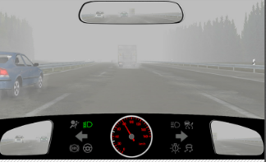 | a) Poor visibility  b) Reduced grip of the tyres on the wet roadway  c) The dipped headlights of oncoming traffic
44.
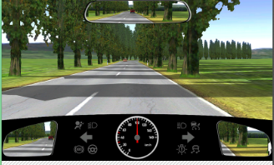 | a) The speed should be adjusted due to the visibility  b) The constant changing of light and shadows makes it more difficult to detect other road users in good time  c) Judging distances is made more difficult because of the constant changing of light and shadows
45.
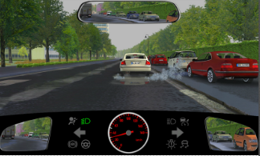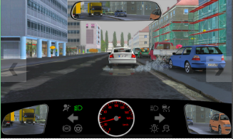
- Because spray water could otherwise impede visibility
- Because the braking distance is longer than on a dry road
- Because uneven areas of the road will otherwise be detected later
46.
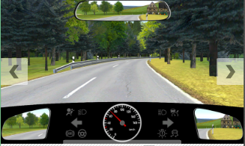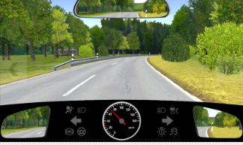
- Wild animals crossing the road
- Fast oncoming traffic cutting the corner
- Slow-moving vehicle on my side of the road
47.
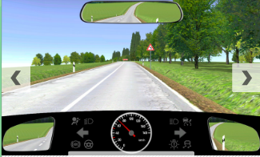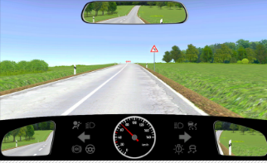
- A dangerous left-hand bend
- An obstacle situated around the corner
- Cross-wise moving traffic before the summit
48.
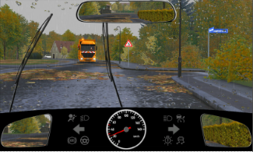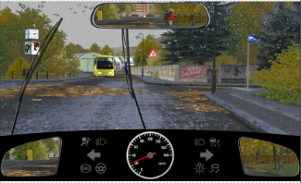
- A narrowed carriageway
- An extended braking distance
- A vehicle coming from the right
49.
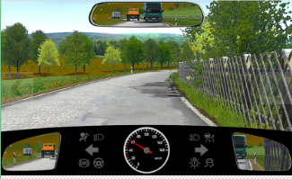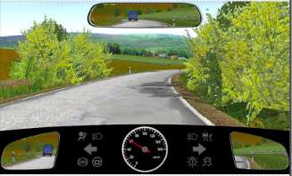
- Because the road surface is uneven
- Because oncoming traffic could cut the corner
- Because it is not clear which direction the road will take
50.
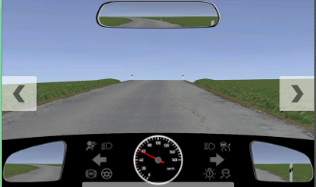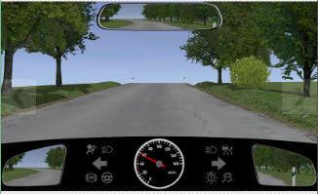
- A vehicle may be stationary there
- There may be a slow moving vehicle on my side of the road
- There may be an oncoming vehicle on my side of the road
51. I should ____________
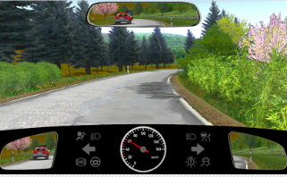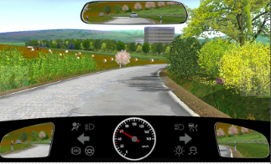
- Greatly reduce my speed
- Continue driving in my lane
- Drive to the left past the damaged road surface
52.
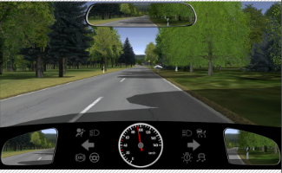 | a) Because I am badly visible to other road users  b) Because I have to give right of way  c) Because the direction of the road ahead demands it
53.
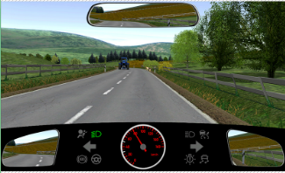 | a) Because of the animal  b) Because of the tractor  c) Because of the course of the road
54. Because of the ______________
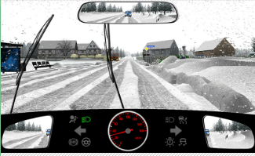 | a) Green car  b) blue car  c) tractor
55.
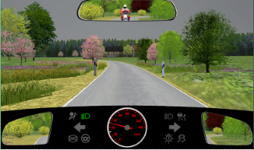 | a) Because of the truck  b) Because of the motorcyclist
56.
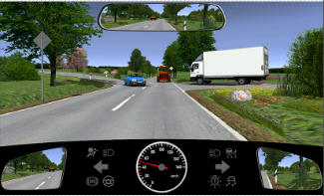 | a) Because of the car  b) Because of the truck  c) Because of the tractor
------------------------------------------------------------------------------------------------------------------------------------------------------
7.3 Speed Regulations
1. 50 km/h (Speed in built-up areas)
2. 100 km/h (Speed outside built-up areas with one marked lane)
3. 100 km/h (Speed of truck with p.t.m 3.0 t with one marked lane)
4. 80 km/h (Speed of car with trailer outside builtup areas)
5. 80 km/h (Speed of truck with gross 3.0 t with trailer outside of settlements)
6.
- I maintain my speed and continue driving as before
- I accelerate in order to create a large enough safety distance
- I brake briefly in order that that the driver behind will reduce the speed
------------------------------------------------------------------------------------------------------------------------------------------------
7.4 Stopping / Braking Distance
1. The condition of the
- Tyres
- Road surface
- Braking system
2. It is 4 times as long
3.
- (Speed in km/h / 10) x (Speed in km/h / 10)
- (Speed in km/h / 10) x 5
- (Speed in km/h / 10) x 3
4.
- 36 m
- 27 m
- 18 m
5. Stopping Distance = 130 m
6. Braking Distance = 100 m
7. Reaction Distance = 30 m
8. Stopping Distance (50 km/h) = 40 m
9. Braking Distance (50 km/h) = 25 m
10. Reaction Distance (50 km/h) = 15 m
11. Evasive braking
- (Speed in km/h / 10) x (Speed in km/h / 10) : 2
- (Speed in km/h / 10 x 5) : 2
- (Speed in km/h / 10 x 3) : 2
12.
- 12.5 m
- 11.0 m
- 9.5 m
13. At a speed of
- 50 km/h
- 30 km/h
- 20 km/h
14. Braking distance changes from
- It is quadrapuled from 25 m to 100 m
- It is doubled from 15 m to 30 m
- It is halved from 50 m to 25 m
15. Reaction distance changes from
- It is doubled from 15 m to 30 m
- It is halved from 50 m to 25 m
- It is quadrapuled from 25 m to 100 m
------------------------------------------------------------------------------------------------------------------------------------------------
7.5 Safety Distances
1.
- Inattentiveness
- Unexpectedly heavy braking
- Driving too close behind the vehicle in front
2.
- Failure to pay attention to other road traffic
- Failure to adjust speed accordingly
- Driving too close to the vehicle in front
3.
- It helps reduce the risk of accidents
- It aids far-sighted driving
- It restricts visibility
4.
- Speed
- Visibility conditions
- State of the road surface
5.
- A “distance of 2 seconds”
- A “distance of 1 second”
- A distance of 15 meters
6.
- 15 m or approximately 3 car lengths
- 10 m or approximately 2 car lengths
- 5 m or approximately 1 car length
7.
- ½ the speedometer reading in meters
- 1/5 the speedometer reading in meters
8.
- As a rule, the distance from a car in front must be great enough to allow an overtaking car to pull in
- The distance from the car in front must not be greater than the length of your combination of vehicles in order to make best use of traffic space
- You may not drive faster than 60 km/h
9. When the combination of vehicles exceeds 7 meters
10. The safety distance should
- Increase to at least 50 m
- Increase to at least 25 m
- Remain the same
11.
- I take the passenger’s comments seriously
- I maintain a greater distance
- I ignore the passenger’s comments
12. VIDEO
- Wait, because otherwise there would not be enough space between the cyclist and the car
- Continue driving as before, because there is sufficient space between the cyclist and the car
- Continue driving at a moderate speed, because there is very little space between the cyclist and the car
13. VIDEO
- Slow down
- Accelerate
- Swerve to the left
14. VIDEO
- Slow down
- Accelerate
- Swerve to the left
------------------------------------------------------------------------------------------------------------------------------------------------

